**INTERNSHIP**

**PROGRAM REPORT**

**NAME :** KAVINKISHORE. E

**ROLL NO :** 201CS034

**DOMAIN :** PYTHON – FLASK - SQLITE-3

**TOPIC :** COMMON EXAMINATION PORTAL

**INDUSTRY PARTNER:** AAKKAM INDUSTRIAL TRAINING

AND RESEARCH INSTITUTE

**INTERN’S PH.NO** : 9080309351

**INTERN’S ADDRESS** : 2/1 Kolingipatty, Kosavan kaadu, Kurukkupuram(po) Rasipuram. Namakkal. 637401

**BRANCH**  : Bsc.Computer Science (Aided)

**NAME OF COLLEGE** : Kongunadu Arts and Science College

**COLLEGE’S ADDRESS** : G.N mills, Thudiyalur, Coimbatore - 641029

**Industry Mentor**  : SANDHIYA CHANDRA SEKAR

**Designation**  : SOFTWARE TRAINER

**Company**  : AAKKAM INDUSTRIAL TRAINING

AND RESEARCH INSTITUTE

**Email ID**  : aakkamKCS@gmail.com

**Contact Number** : 8870546052

**TABLE OF CONTENTS**

|  |  |  |
| --- | --- | --- |
| **CHAPTER** | **CONTENT** | **PAGE NO** |
| 1 | COMPANY PROFILE | 4 |
| 2 | SYSTEM SPECIFICATION | 6 |
| 3 | ABOUT PROJECT | 11 |
| 4 | DETAILED DESCRIPTION ON SPECIALIZED DEPARTMENT | 14 |
| 5 | CONCLUSION | 32 |

**CHAPTER 1**

**COMPANY PROFILE**

**Aakkam Industrial Training and Research Institute** as a join collaboration of Core members from software industry and Training sector with a vast experience and knowledge. This was started as an initiative project on educating the young aspirants to provoke and guide them towards pursuing a successful professional career in their respective specializations of this highly competitive global economy. Aakkam is on a mission to educate on technology rather than focusing on providing international certifications by sticking to our one of our quality policy **“Only Knowledge Matters”**.



**What we Do?**

**Aakkam Industrial Training and Research Institute** provides training solutions for competitive exams ,government exams , entrance coaching for medical , engineering and higher studies, job assured professional training for colleges of all departments. Aakkam provides training on Industry Centric syllabus that will have a positive impact on placement opportunities. Our key focus of training starts from the roots of core technologies that are mandatory for job assurance. We stick to the principle of quality education and so our trainers are in 24 / 7 mission to learn new technologies and delivering it with professionalism to our future technocrats, accounting managers, and young entrepreneurs.

**1.1 How we Do?**

Knowledge is knowing and edging towards learning it. Knowledge is a global assert it must be distributed evenly through all kinds of people. We provide such a kind of knowledge expansion through our Seminars, Guest lectures, Workshops and Value added programs at all educational, training institutes.

**1.2 Application Development**

AAKKAM Application development services, provide an IT backbone for our clients. Our Applications helps our clients to enrich their business model, which pay backs their Return on Investment (ROI).

**1.3 SEO service**

With our SEO professional experts, we help to optimize your website from scratch and equip it with the necessary tools that enable the website to stay one step ahead of the search engines

**1.4 Software Training**

At AAKKAM, we are committed to provide carrier oriented training programs to the aspiring young talents in IT industry. Our AAKKAM Experts with deep knowledge on their specific domains and technologies share and train the young talents to excel in the Industry.

**1.5 Consultancy service**

With our expertise group we provide consultancy services for our clients on Application Migration, implementation and maintaince. At AAKKAM we also provide HR consultancy services to our placement partner.

**CHAPTER 2**

**SYSTEM SPECIFICATION**

**2.1 HARDWARE REQUIREMENTS**

* Processor : I3
* Hard disk : 500 GB
* Mouse : Logitech.
* RAM : 4GB(minimum)
* Keyboard : 110 keys enhanced.

**2.2 SOFTWARE REQUIREMENTS**

* IDE : Visual studio code/ Pycharm IDE
* Front End : PYTHON
* Back End : MYSQL/ SQLITE-3
* Design : HTML,CSS, Flask-Wt Forms, Jinja
* Browser : Internet explorer, Firefox.
* Operating system : Windows 10/ 11

**2.3 SOFTWARE DESCRIPTION**

**PYTHON LANGUAGE INTRODUCTION**

Python is a widely used general-purpose, high level programming language. It was initially designed by Guido van Rossum in 1989 and developed by Python Software Foundation. It was mainly developed for emphasis on code readability, and its syntax allows programmers to express concepts in fewer lines of code.Python is a programming language that lets you work quickly and integrate systems more efficiently.

* There are two major Python versions- Python 2 and Python 3. Both are quite different.
* Windows: There are many interpreters available freely to run Python scripts like IDLE (Integrated Development Environment ) which is installed when you install the python software from http://python.org/
* Linux: For Linux, Python comes bundled with the Linux.

**LANGUAGE FEATURES**

**Interpreted**

* There are no separate compilation and execution steps like C and C++.
* Directly run the program from the source code.
* Internally, Python converts the source code into an intermediate form called byte codes which is then translated into native language of specific computer to run it.
* No need to worry about linking and loading with libraries, etc.

**Platform Independent**

* Python programs can be developed and executed on multiple operating system platforms.
* Python can be used on Linux, Windows, Macintosh, Solaris and many more.

**Free and Open Source**: Re-distributable

**High-level Language**

* In Python, no need to take care about low-level details such as managing the memory used by the program.

**Simple**

* Closer to English language;Easy to Learn
* More emphasis on the solution to the problem rather than the syntax

**Embeddable**

* Python can be used within C/C++ program to give scripting capabilities for the program’s users.

**Robust**:

* Exceptional handling features
* Memory management techniques in built

**Rich Library Support**

* The Python Standard Library is vary vast.
* Known as the “batteries included” philosophy of Python ;It can help do various things involving regular expressions, documentation generation, unit testing, threading, databases, web browsers, CGI, email, XML, HTML, WAV files, cryptography, GUI and many more.
* Besides the standard library, there are various other high-quality libraries such as the Python Imaging Library which is an amazingly simple image manipulation library.

**FLASK FRAMEWORK**

If developing a web app in Python, chances are leveraging a framework. A framework "is a code library that makes a developer's life easier when building reliable, scalable, and maintainable web applications" by providing reusable code or extensions for common operations. There are a number of frameworks for Python, including Flask, Tornado, Pyramid, and Django. New Python developers often ask: Which framework should I use?

Flask is a relatively new framework that has taken the Python web development community by storm: in a short time it became one of the most popular frameworks around. It offers a lot of flexibility and clean code with a lot of extensibility. No feeling dragged down by a huge framework that tells you what to do; instead, you’ll feel free, productive, and creative!

**MySQL**

A database is a separate application that stores a collection of data. Each database has one or more distinct APIs for creating, accessing, managing, searching and replicating the data it holds.Other kinds of data stores can be used, such as files on the file system or large hash tables in memory but data fetching and writing would not be so fast and easy with those types of systems.So nowadays, using relational database management systems (RDBMS) to store and manage huge volume of data. This is called relational database because all the data is stored into different tables and relations are established using primary keys or other keys known as foreign keys.

A Relational DataBase Management System (RDBMS) is software that:

* Enables you to implement a database with tables, columns and indexes.
* Guarantees the Referential Integrity between rows of various tables.
* Updates the indexes automatically.
* Interprets an SQL query and combines information from various tables.

**RDBMS Terminology:**

Before we proceed to explain MySQL database system, let's revise few definitions

related to database.

* Database: A database is a collection of tables, with related data.
* Table: A table is a matrix with data. A table in a database looks like a simple spreadsheet.
* Column: One column (data element) contains data of one and the same kind, for example the column postcode.
* Row: A row (= tuple, entry or record) is a group of related data, for example the data of one subscription.
* Redundancy: Storing data twice, redundantly to make the system faster.
* Primary Key: A primary key is unique. A key value can not occur twice in one table. With a key, you can find at most one row.
* Foreign Key: A foreign key is the linking pin between two tables.
* Compound Key: A compound key (composite key) is a key that consists of multiple columns, because one column is not sufficiently unique.
* Index: An index in a database resembles an index at the back of a book.
* Referential Integrity: Referential Integrity makes sure that a foreign key value always points to an existing row.

**Sqlite 3 Database:**

* SQLite is an in-process library that implements a [self-contained](https://www.sqlite.org/selfcontained.html), [server less](https://www.sqlite.org/serverless.html), [zero-configuration](https://www.sqlite.org/zeroconf.html), [transactional](https://www.sqlite.org/transactional.html) SQL database engine. The code for SQLite is in the [public domain](https://www.sqlite.org/copyright.html) and is thus free for use for any purpose, commercial or private. SQLite is the [most widely deployed](https://www.sqlite.org/mostdeployed.html) database in the world with more applications than we can count, including several [high-profile projects.](https://www.sqlite.org/famous.html)
* SQLite is an embedded SQL database engine. Unlike most other SQL databases, SQLite does not have a separate server process. SQLite reads and writes directly to ordinary disk files. A complete SQL database with multiple tables, indices, triggers, and views, is contained in a single disk file. The database [file format](https://www.sqlite.org/fileformat2.html) is cross-platform - you can freely copy a database between 32-bit and 64-bit systems or between [big-endian](http://en.wikipedia.org/wiki/Endianness) and [little-endian](http://en.wikipedia.org/wiki/Endianness) architectures. These features make SQLite a popular choice as an [Application File Format](https://www.sqlite.org/appfileformat.html). SQLite database files are a [recommended storage format](https://www.sqlite.org/locrsf.html) by the US Library of Congress. Think of SQLite not as a replacement for [Oracle](http://www.oracle.com/database/index.html) but as a replacement for [fopen()](http://man.he.net/man3/fopen)
* The SQLite code base is supported by an [international team](https://www.sqlite.org/crew.html) of developers who work on SQLite full-time. The developers continue to expand the capabilities of SQLite and enhance its reliability and performance while maintaining backwards compatibility with the [published interface spec](https://www.sqlite.org/c3ref/intro.html), [SQL syntax](https://www.sqlite.org/lang.html), and database [file format](https://www.sqlite.org/fileformat2.html). The source code is absolutely free to anybody who wants it, but [professional support](https://www.sqlite.org/prosupport.html) is also available.

**CHAPTER 3**

**ABOUT PROJECT**

This project is based on the concept of both registration and preparation for competitive exams. The site has registration options for various of competitive exams like JEE, NEET, TNPSC etc and also preparation kits for that exams. The users can register themselves and download the necessary preparation materials and can also query on the doubts to the respective heads of the examination.

Each of the heads in the site are monitored by the admin. Any updates or activity done by the heads are reviewed and approved by admin. The respective heads of the department adds updates about exams, uploads study materials, quizes, generate hall tickets for users. The users can register themselves and use the options in the websites. The users can take upon quizes, download study materials, get updates about exams. The site is more user-friendly and simple to use and it is straight forward in bringing all the necessary information required for its users.

**PROJECT DESCRIPTION**

The “ online competitive exams portal “ project targets an achieving a common website where users can register , learn, get update on a single platform . The user once registered can access all the facilities of the site . The Admin is the the soul controller of the full website. All the registered user actives are monitored by the head . Uploading exam , adding update , adding quizzes , approving users hall ticket for exam’s registered etc are some of the tasks undertook by the head . There is at least one head for every department or category of the exams an user may register. Every head in the website are added by the admin. Every form data in the website are handled by Flask-Wt Forms, a simple and rigid python extension that handles users request to server and vice versa. Its GUI is simple and attractive. Every user in the website are provide with ID and password once they are registered and each time they access the lite they are prompt to login with there ID and password. All the users credentials are stored in the table as 16digit encrypted value.

The project’s main goal is to achieve a safe and simple surfing experience across the site . Being implemented with SQLite 3 back end database and Flask-Wt forms . The user’s data are safe to CSRF vulnerability and such activities .The GUI of the website is simple ,so that users have no difficulty in making use of the site end provide a hassle free using experience .

**3.2 SYSTEM STUDY**

System study is classified into two types

* Existing system and
* Proposed system

**3.2.1 EXISTING SYSTEM**

The system that existed had features for registering the exams but registeration for each category of exam were present on different websites and each had its own rules and regulations for applying. Not only that, there are no options for applicants to get study materials from the registered sites itself, all they have to do was self study. To make use of the site, one had to face great difficulty and most of the times the applicants opt for computer centres for the registration of the exams.

**DISADVANTAGES**

* Each exam application were present on different sites.
* Rules and regulations for applying were tenacious .
* No study materials available on the registered website.
* Applicants had to seek help of registration centres for applying.

**3.2.2 PROPOSED SYSTEM**

In the new designed system, the users can register the various exams in differnet categories using the same website itself. The website itself is pretty much straight forward and simple to use, were the applicants themselves can register for their exams without seeking the help of others.

Also the site provides study materials for the registered exams where the students can prepare themselves through pdfs, Subject Quizzes and previous year Question Papers.

**ADVANTAGES**

* Registration for every exams is present in a common website
* Easy and straight forward website
* Preparation materials for every exams
* Easy registration and Payment features.

**CHAPTER 4**

**DETAILED DESCRIPTION ON SPECIALIZATION DEPARTMENT**

Department under which undergone training are:

1. Designing
2. Development
3. Testing

**4.1 DESIGNING**

**DATA FLOW DIAGRAM**

A data flow diagram is graphical tool used to describe and analyse movement of data through a system. These are the central tool and the basis from which the other components are developed. The transformation of data from input to output, through processed, may be described logically and independently of physical components associated with the system. These are known as the logical data flow diagrams. The physical data flow diagrams show the actual implements and movement of data between people, departments and workstations. A full description of a system actually consists of a set of data flow diagrams. Using two familiar notations Yourdon, Gane and Sarson notation develops the data flow diagrams. Each component in a DFD is labeled with a descriptive name. Process is further identified with a number that will be used for identification purpose. The development of DFD’S is done in several levels. Each process in lower level diagrams can be broken down into a more detailed DFD in the next level. The lop-level diagram is often called context diagram. It consists a single process bit, which plays vital role in studying the current system. The process in the context level diagram is exploded into other process at the first level DFD.

|  |  |  |  |
| --- | --- | --- | --- |
|  |  |  |  |
| Process that tranform data flow | Source of data | Data flow | Data Store |

**LEVEL-0:**

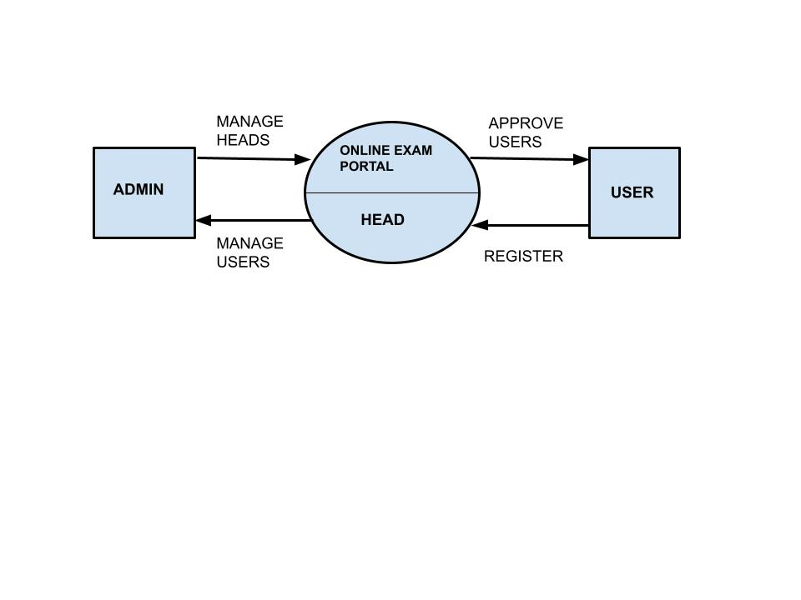

LEVEL-0: DFD FOR **COMMON COMPETITIVE EXAMS PORTAL**

**LEVEL-1:**

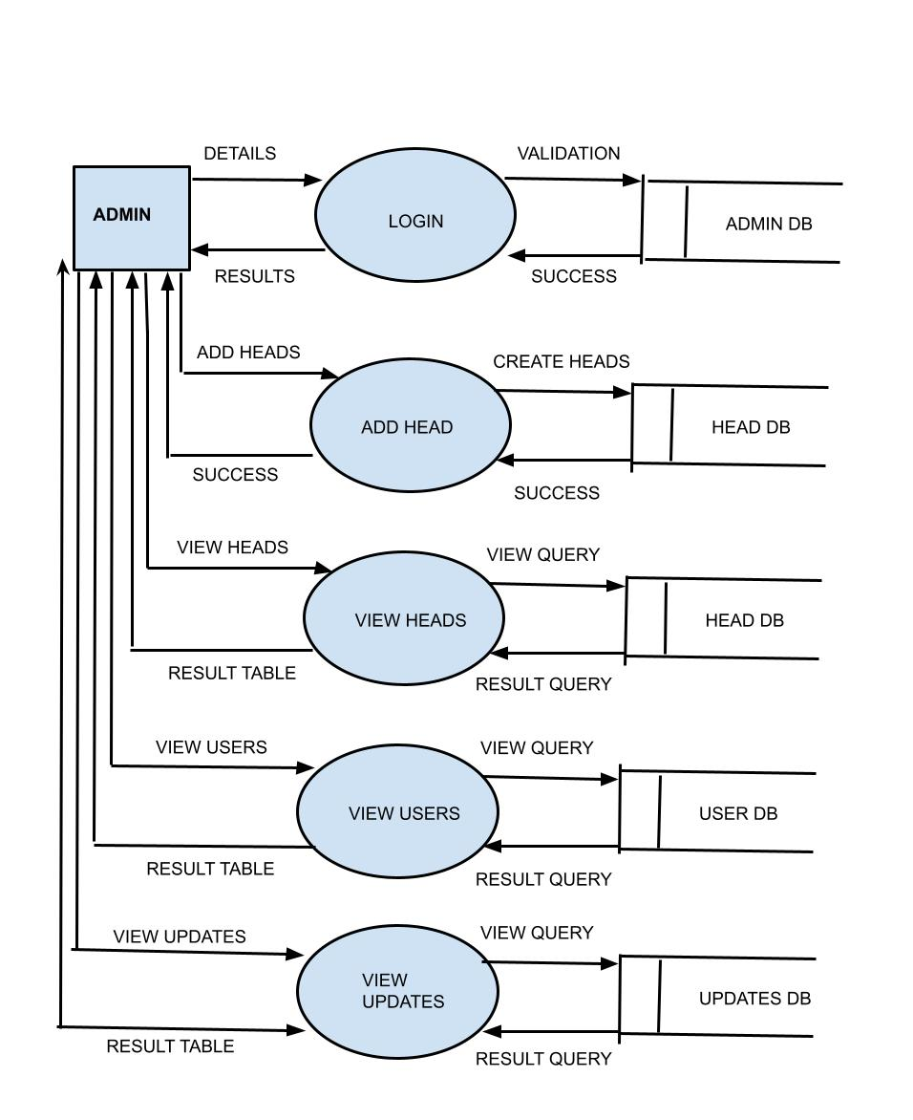**4.2**

LEVEL-1: DFD FOR **COMMON COMPETITIVE EXAMS PORTAL**

**LEVEL-2:**

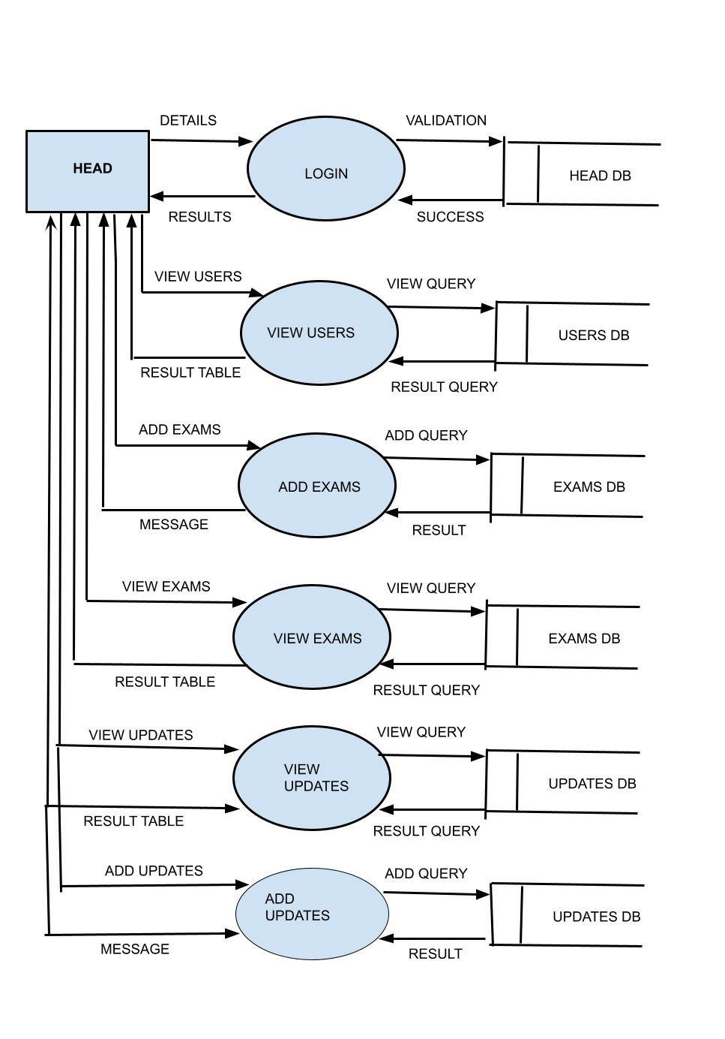

LEVEL-2: DFD FOR **COMMON COMPETITIVE EXAMS PORTAL**

**LEVEL-3:**

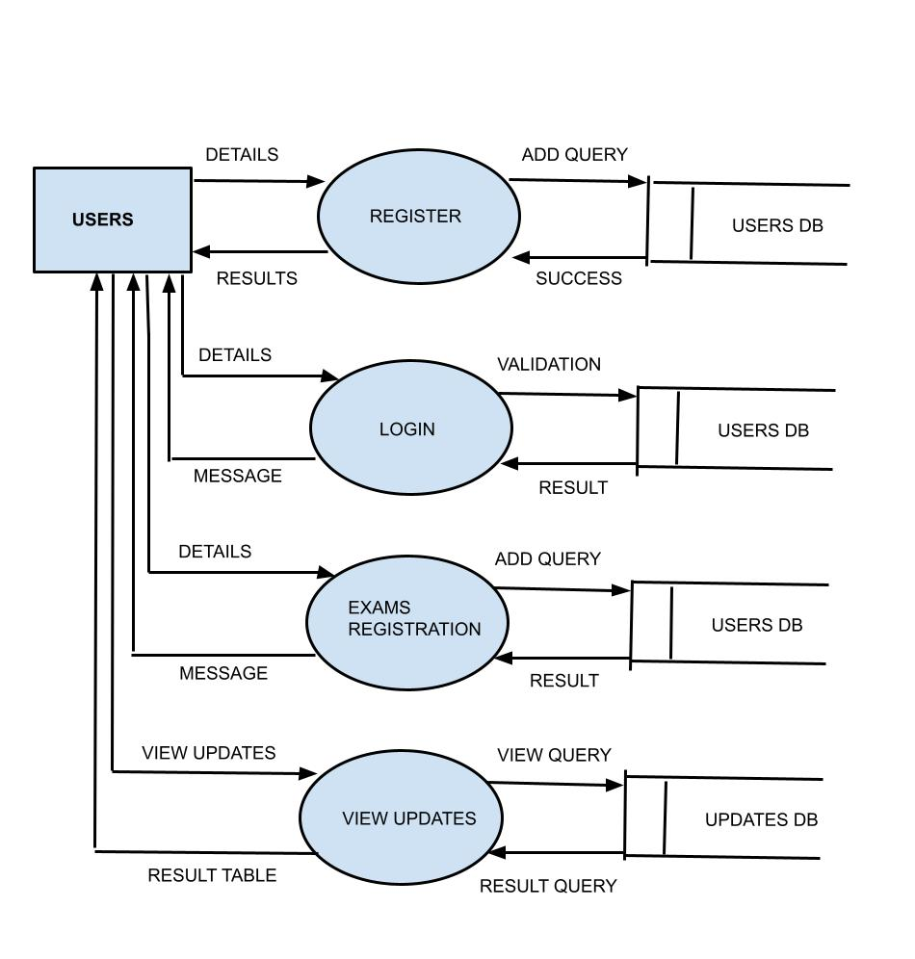

LEVEL-3: DFD FOR **COMMON COMPETITIVE EXAMS PORTAL**

**4.2 DEVELOPMENT**

**MODULE DESCRIPTION**

**MODULES:**

* Admin
* Head
* User

**Admin:**

**Sub module:**

* **Login –** Username and password are required for specific Admin login.
* **Add Head –** Respective heads for the departments and their details are added here by admin.
* **View Heads –** All the heads in the department added by the admin are viewed in this option.
* **View Users –** All the users registered in the website are viewed in this option by the admin.

**Head:**

**Sub module:**

* **Login -**  All the heads for the respective department are required to login using their username and password.
* **Add exams -**  Exams for which the users can register are added using this option.
* **Add updates –** Any events, announcements, Date for appearence of exam, etc are updated under this option.
* **View Users –**  All the users registered in the website and has a account are viewed in this option.
* **View Upadtes –**  Updates(notifications) announced by every head in the website are viewed in this option.
* **View exams –** All the exams and their details are viewed in this option by the heads.

**Users:**

**Sub module:**

* **Register –** Users registration for the website are done through this option.
* **Login –** All the registered users can login to the website using their username and password.
* **View updates –** All the updates from the heads like exam dates, hall ticket approval etc are reminded to the user through this option.
* **Exam Registration –** Users can register themselves for thier preffered exams using this option.

**4.3 TESTING**

**Need for Testing**

1. To click the efficiency of the system
2. To remove the errors of the system
3. To check whether the objectives of the project is accomplished
4. To enable the removal of complexities
5. To check the user-friendliness of the system
6. To check the flexibility of the system.

**VALIDATION TESTING**

This is easy generalized for Object Oriented languages by using the equivalent constructs for message passing. In the following, the word “call” is to be understood in the most general sense of a data flow and is not restricted to just formal subroutine calls and returns.In integration testing the high level control routines are tested first, possibly with the middle level control structures presents only as **stubs.** Subprogram stubs were presented in Section 2 as incomplete subprograms which are only present to allows the high level menu driver to be tested.

Since the addition and modification takes place in a single form according to the called menu item, the validation testing testing for various forms and their procedure were tested carefully. Almost all forms call public Functions form the modules. The integration testing was done for all called function

**TESTING DONE IN THE SYSTEM:**

**Admin:**

* Whether login details are provided
* Checking the field and datatype matches
* Validating length specifications for password.
* Check whther usernames and their email are unique.

**Head:**

* Whether login details are provided
* Checking the field and datatype matches
* Validating length specifications for password.
* Check whther usernames and their email are unique.
* Checking date formats
* Check if the value email is entered in correct format.

**User:**

* Check if the user exists
* Check userid and password meets requirements specified.
* Check if data is entered when a form is submitted.

**4.4 FINAL OUTCOME**

**Index page**

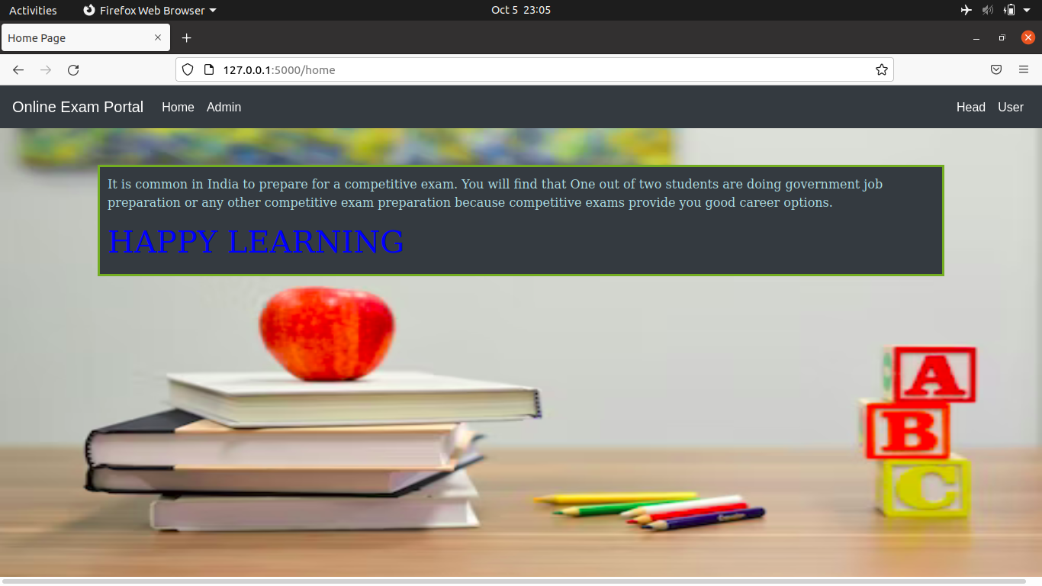Fig 1.0

This page is the opening window for all user and contain main navigation.

**Admin Login**

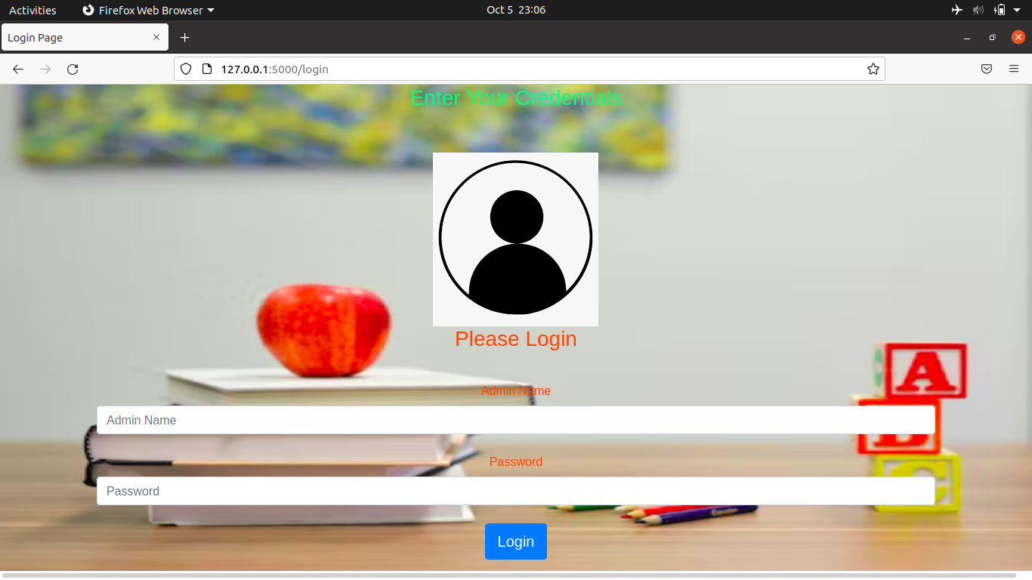Fig1.1

Admins Login using their username and password.

**Admin Home**

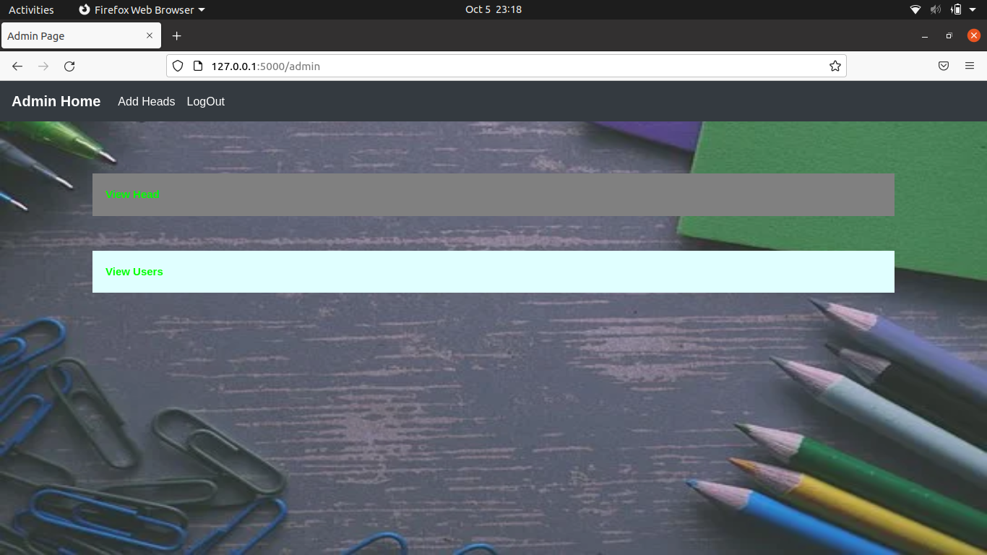Fig 1.2

Page contains Main navigation for Admin

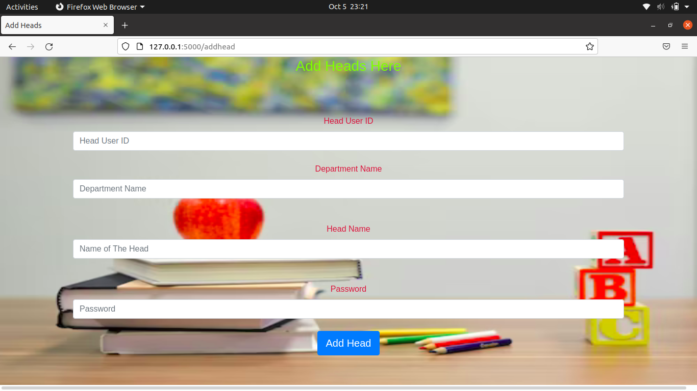**Add Head**

Fig1.3

Admins add heads here.

**View Users**

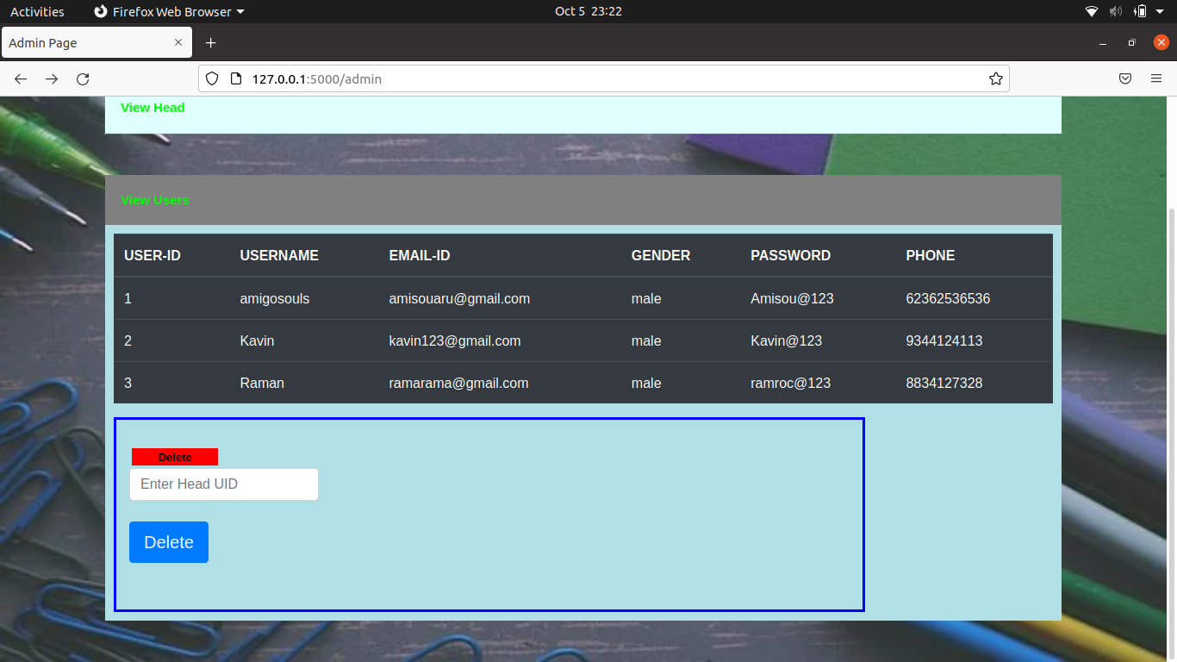Fig 1.4

Admin views all registered Users

**View Heads**

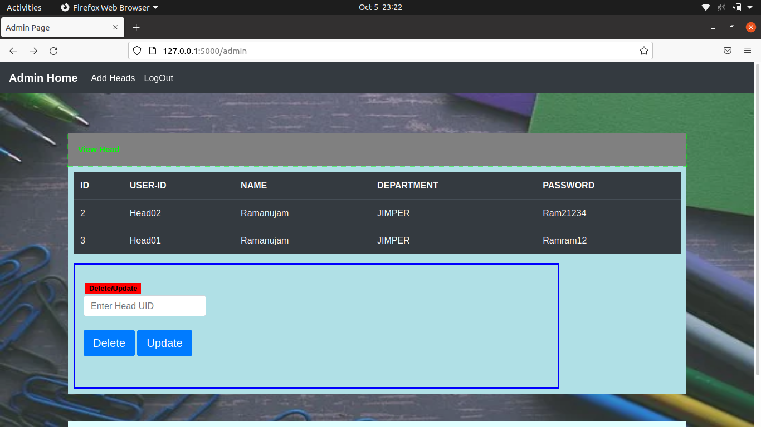Fig 1.5

All heads are viewed here.

**Head Login**

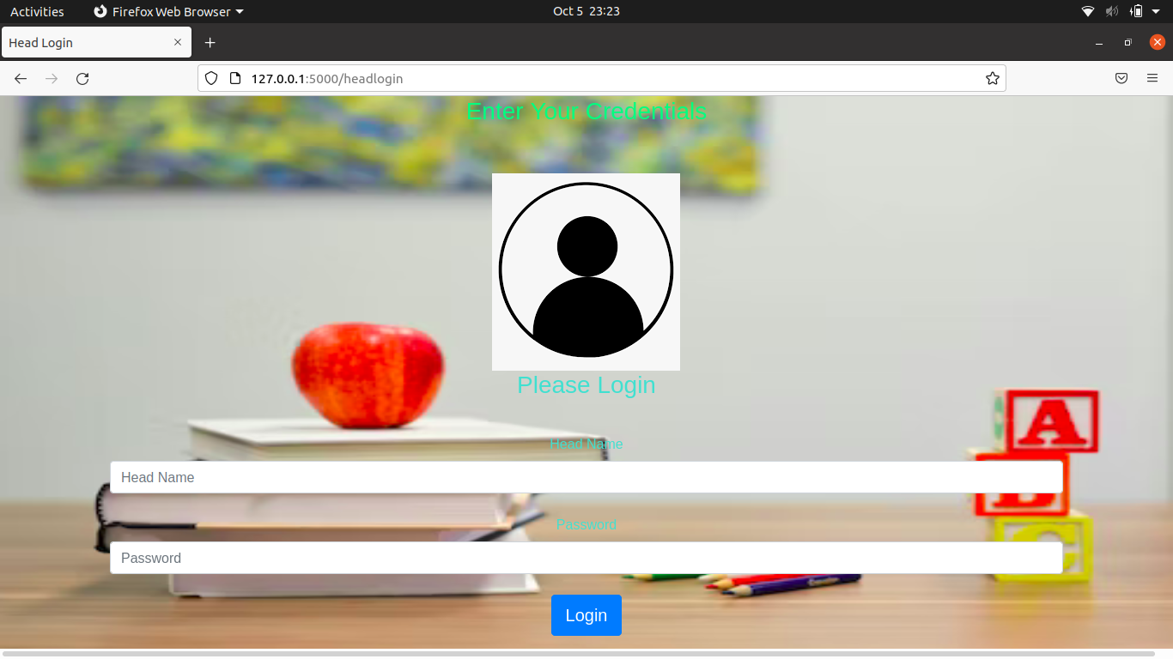Fig 1.6

All heads login through this page.

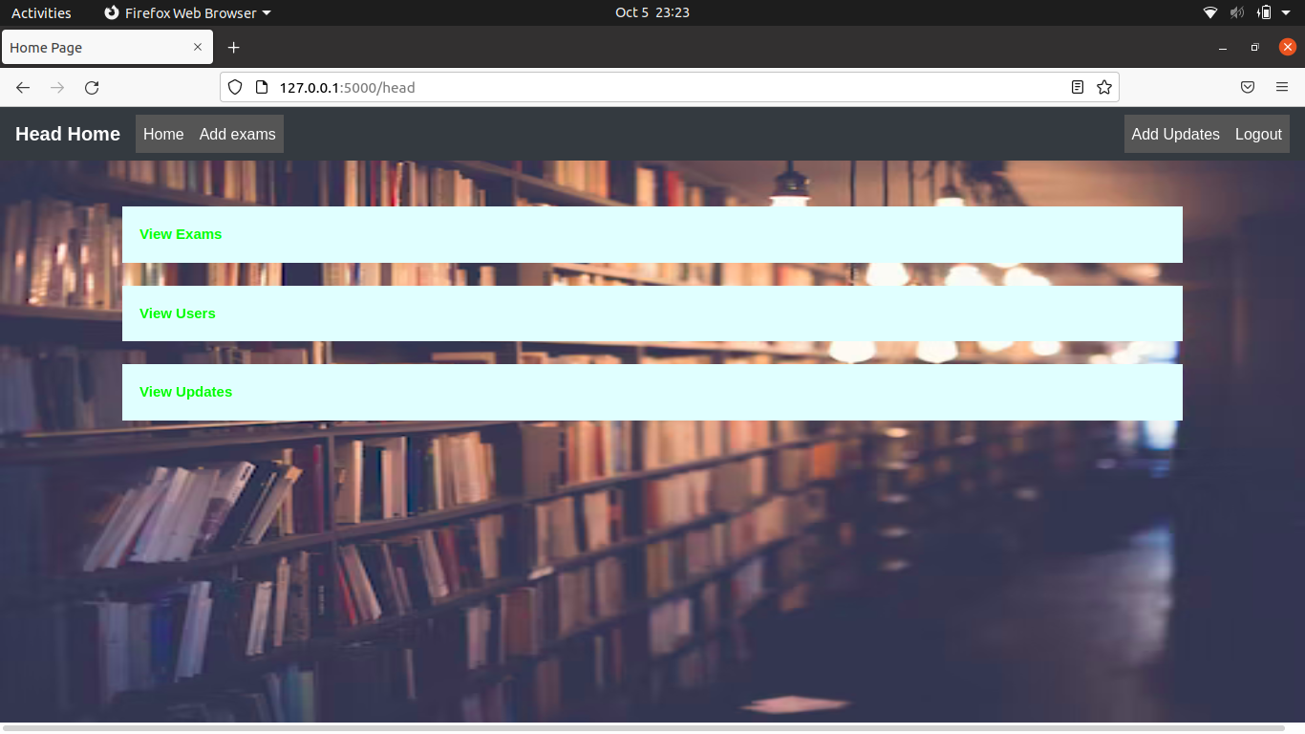**Head Home**

Fig 1.7

Head users main navigation page.

**Add Exams**

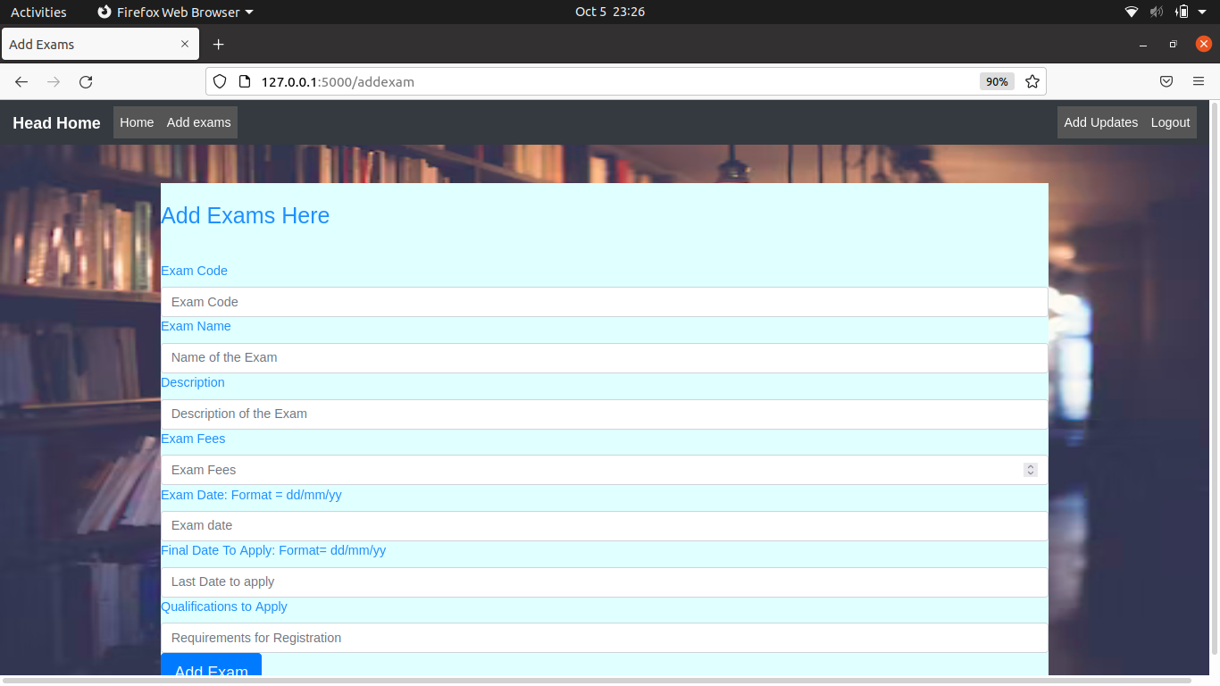Fig 1.8

Heads adds exams through this form.

**Add update**

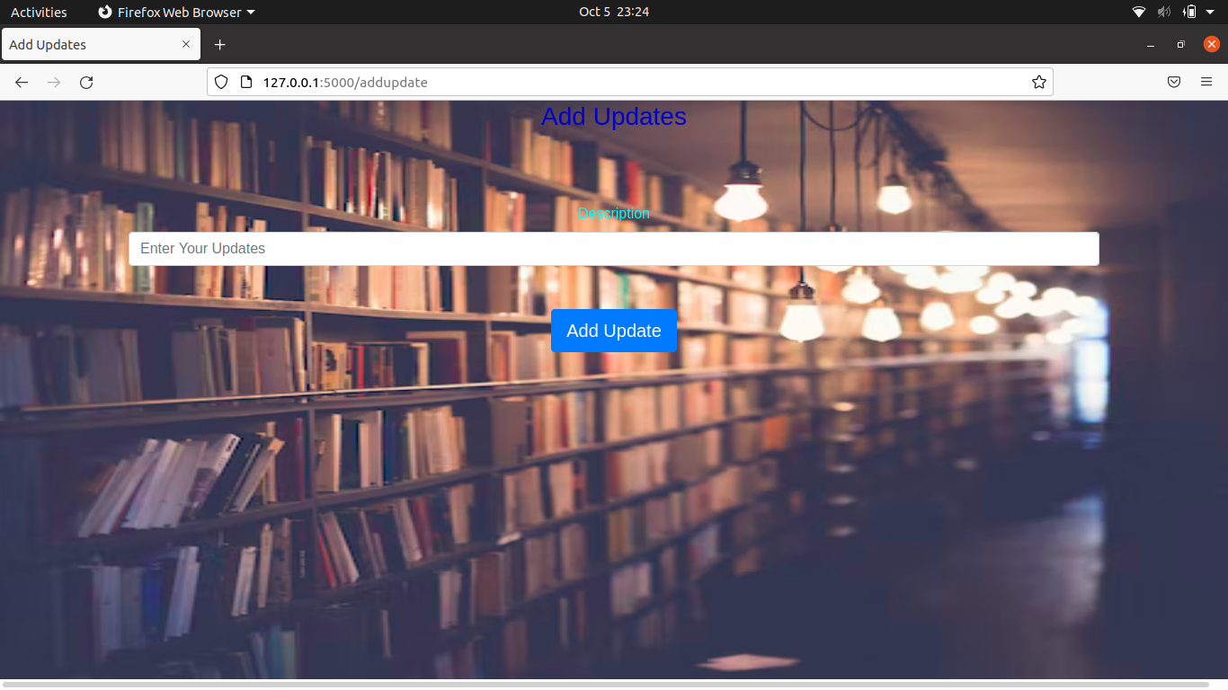Fig 1.9

Adds notification for users by head.

**View Users**

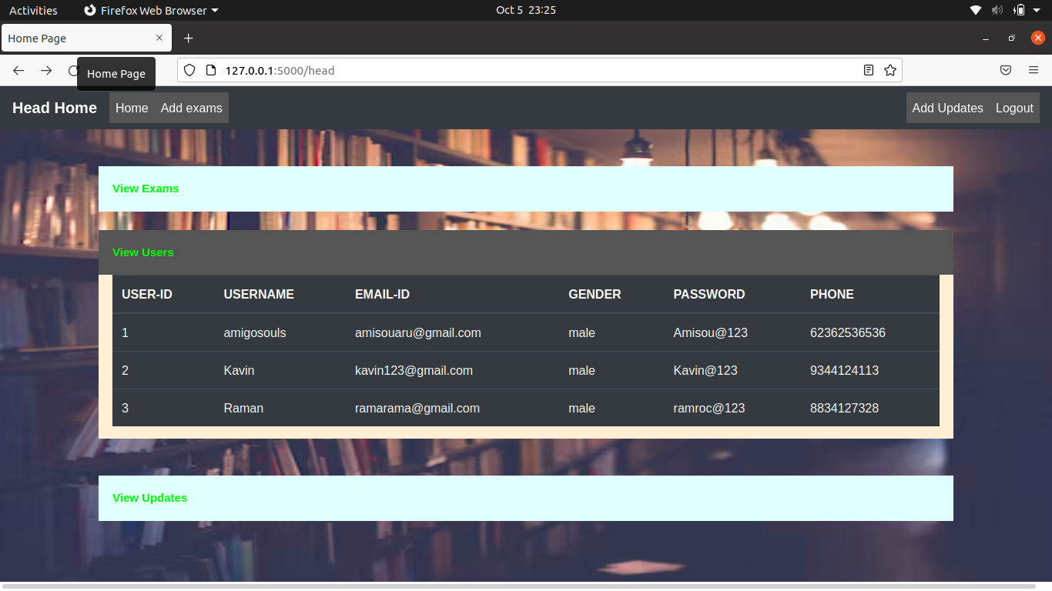Fig 1.10

Heads view registered users here.

**View Exams**

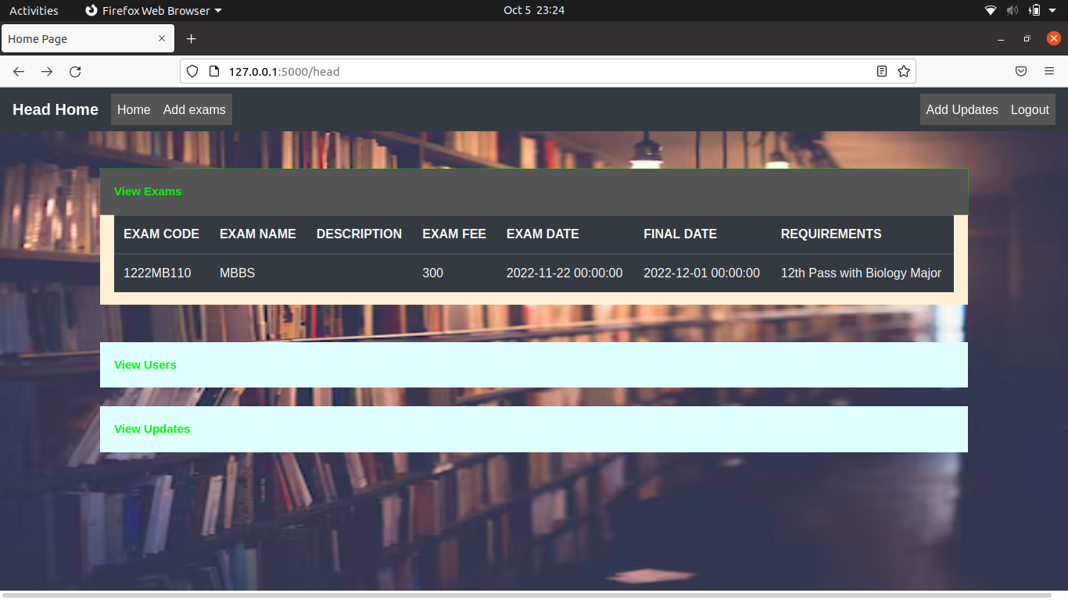Fig 1.11

Heads Views Exams

**View Updates**

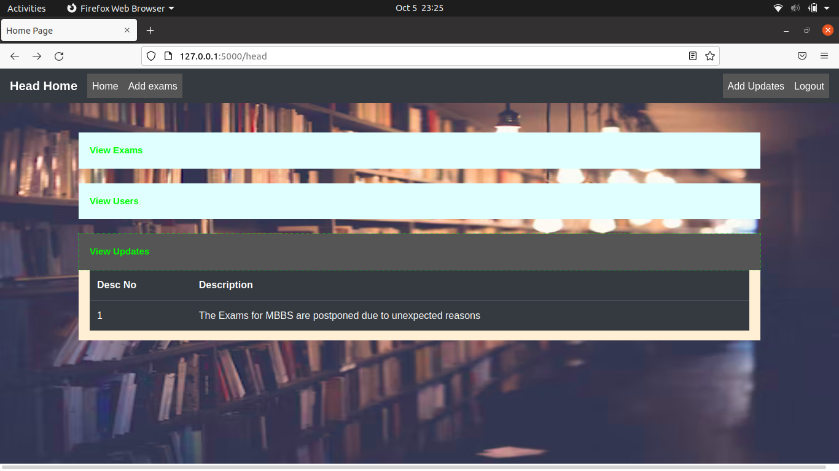Fig 1.12

Heads view the updates created.

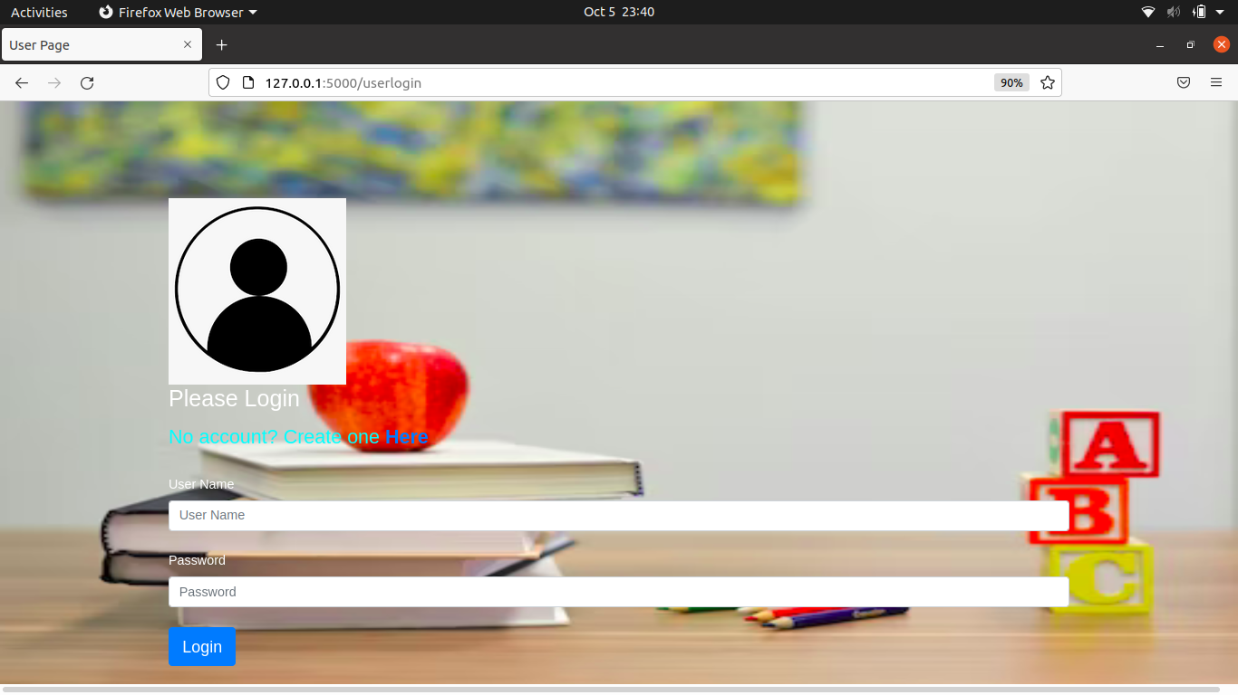**User Login**

Fig 1.13

Users Login using this form.

**User Home**

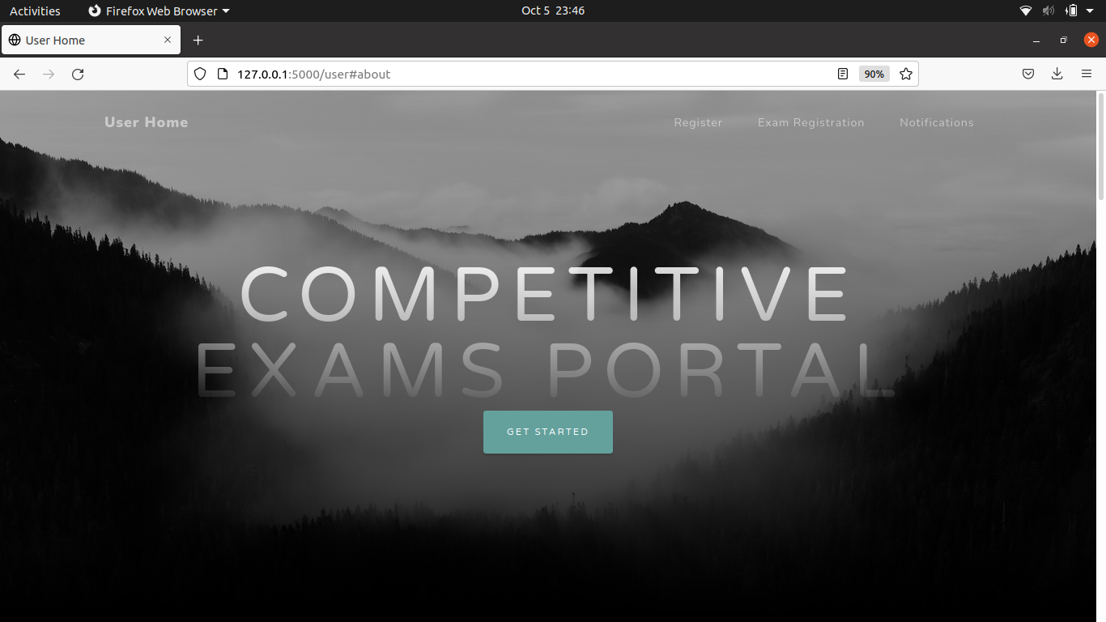Fig 1.14

Users main navigation window.

**Register**

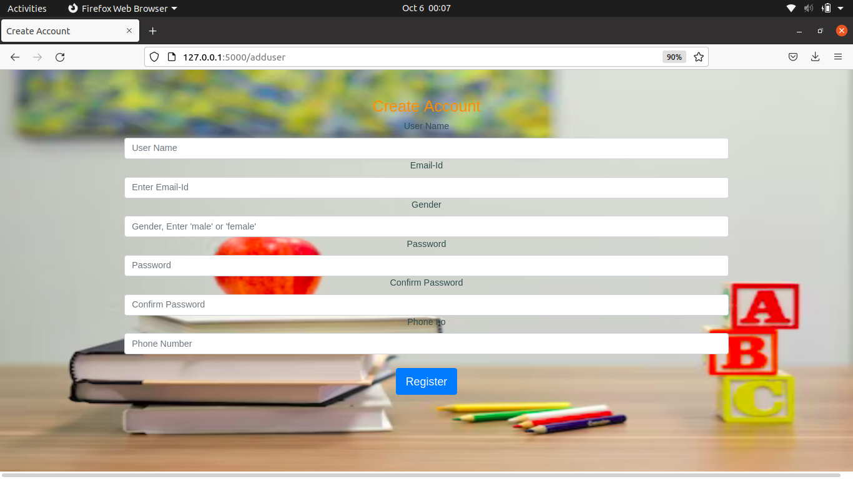Fig 1.15

New Users Registration form.

**CHAPTER 5**

**CONCLUSION**

The 20 days Internship program offered by the KCS Aakkam Training and Research institute

was worth learning and exciting. I’ve gained enough experience to work with Python – Flask

Web Framework and to design a website from scratch. Not only technical skills, but also I’ve

gathered skills of teamwork and communication. I’ve gained knowledge about how a project

will be handled in a company and also what are the sub-tasks that follows after a project

completion. The overall experience of this internship program was positive and its much

helpful in my career.

**TIMESHEET**

|  |  |  |
| --- | --- | --- |
| **S.NO** | **DATE** | **TOPIC COVERED** |
| 1 | 09/08/22 | Internship process and self introduction |
| 2 | 13/08/22 | Python Installation and overview |
| 3 | 14/08/22 | Python functions and datatypes |
| 4 | 19/08/22 | Project titile selection and installation |
| 5 | 20/08/22 | Installing Flask and Configuring extensions |
| 6 | 21/08/22 | Designing of the Admin page layouts and routes |
| 7 | 27/08/22 | Designing of the Head page layouts and routes |
| 8 | 28/08/22 | Desinging of the User page layouts and routes |
| 9 | 03/09/22 | Sqlite-3 download and database creation |
| 10 | 04/09/22 | Creation of login forms using WT forms |
| 11 | 17/09/22 | Connection of forms with with databases |
| 12 | 18/09/22 | Validation of Data in forms of login and add pages |
| 13 | 24/09/22 | Update and delete codes were written |
| 14 | 25/09/22 | Project description and DFD were created |
| 15 | 01/10/22 | Module description were created |
| 16 | 02/10/22 | Testing and conclusion |
| 17 | 04/10/22 | Documentation completion |
| 18 | 05/10/22 | PPT completion |
| 19 | 08/10/22 | Final review |
| 20 | 09/10/22 | Project conclusion |